**Name: Abdul Ahad**

**Roll no: CS-22139**

**AI – Lab 04**

Develop a MATLAB program for OR function with bipolar inputs and targets using Adaline network. The truth table for the OR function with bipolar inputs and targets is given as,

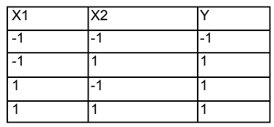

ANSWER:

clear all;

clc;

disp("ADALINE NETWORK FOR OR FUNCTION BIPOLAR INPUTS AND TARGET");

i1 = [1 1 -1 -1];

i2 = [1 -1 1 -1];

%bias input

i3 = [1 1 1 1];

%target vector

t = [1 1 1 -1];

% Assigning initial networks weights and bias

w1 = 0.1;

w2 = 0.1;

b = 0.1;

%First initializing the learning rate

alpha = 0.1;

%error convergence

e = 0;

%change in weights and bias

delwl = 0;

delw2 = 0;

delb = 0;

epoch = 0;

while(e < 0.5)

epoch = epoch + 1;

e = 0;

for j = 1:4

finaly(j) = w1 * i1(j) + w2 * i2(j) + b;

%Inet input calculated and targeted

nt = [finaly(j) t(j)];

delwl = alpha * (t(j) - finaly(j)) * i1(j);

delw2 = alpha * (t(j) - finaly(j)) * i2(j);

delb=alpha * (t(j) - finaly(j)) * i3(j);

%Weight changes

wc = [delwl delw2 delb];

%updation of weights

wl = w1+delwl;

w2 = w2+delw2;

b = b + delb;

%new weights

w = [wl w2 b];

%input pattern

i = [i1(j) i2(j) i3(j)];

%now printing output

out = [i nt wc w]

end

for k=1:4

finaly(k) = w1 * i1(k) + w2 * i2(k) + k

e=e + (t(k) - finaly(k)) ^ 2;

end

if epoch == 1

end

end end

for i = 1:4

nety(i) = w1 * x1(i) + w2 * x2(i) + b;

e = e + (t(i) - nety(i)) ^ 2;

end

end